**Instructions for Tiff16 Analyzer**

1. Install the software by running “setup.exe” and following the onscreen instructions.
2. Copy the three “.dll” files from the installation folder to the folder where you installed the software.
3. Press the “Tiff16 Analyzer” to open the software.
4. On the main panel choose the menu bar option “Image->Channels ratio->Multi” and this will open a new panel:

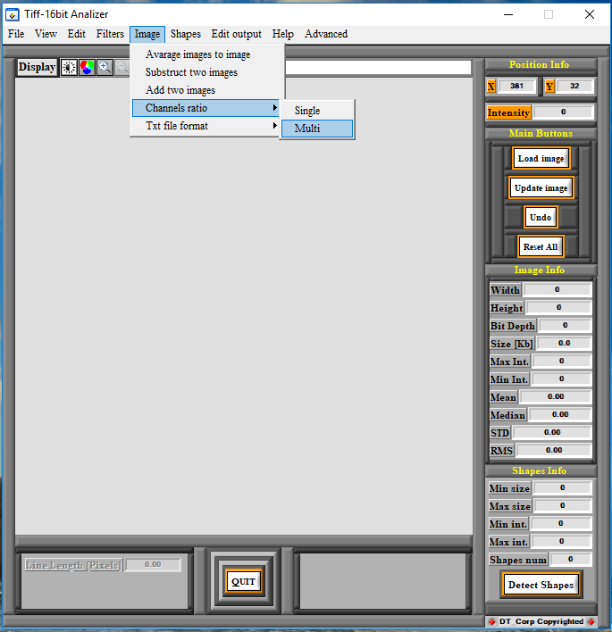

1. In the new panel you can set the detection parameters of the main image with the DNA molecules (Green) and two reference channels with DNA labels (Red and Blue). To activate third channel please check the box “Activate”. The panel looks like this:

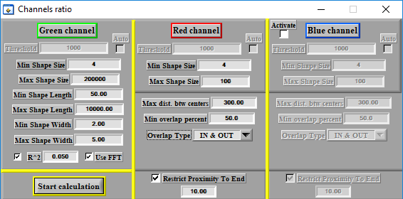

***For main channel (Green):***

* 1. “Threshold” – the minimum intensity of a pixel to be considered as a signal – it is disabled when “Use FFT” is on or when “auto” is checked and calculated automatically by the software for every image.
  2. “Min/Max Shape Size” – minimum and maximum shape size in pixels – shapes smaller than min or bigger than max will be discarded.
  3. “Min/Max Shape Length” – minimum and maximum shape length in pixels – shapes shorter than min or longer than max will be discarded.
  4. “Min/Max Shape Width” – minimum and maximum shape width in pixels – shapes with width smaller than min or bigger than max will be discarded.
  5. “R^2” – if checked filters the detected shapes by their linearity – the smaller the number is the more straight the detected molecules are.
  6. “Use FFT” – applies filtering for improved detection results (not always improves and might introduce noise – use with caution).

***For labels/reference channels (Red and/or Blue):***

1. “Threshold” – the minimum intensity of a pixel to be considered as a signal – it is disabled when “Use FFT” is on or when “auto” is checked and calculated automatically by the software for every image.
2. “Min/Max Shape Size” – minimum and maximum shape size in pixels – shapes smaller than min or bigger than max will be discarded.
3. “Max dist. Btw centers” – an internal factor used by the software and affects the overlay of the detected molecules in the different channels. This factor has to be about half the length of the longest DNA molecules detected in the data set. Bigger values will not affect the results but only increase calculation times. Smaller values might introduce a bios to the results.
4. “Min overlap percent” – the percentage of the overlay of two molecules – when the molecules do not overlap the percent is 0 and when one shape encloses the other entirely the percentage is 100. Molecules that overlay with percentage higher than specified will be considered as overlapped and with lower will be discarded.
5. “Overlap Type” – the way the overlay is calculated – usually “In & Out” gives better results.
6. “Restrict Proximity to End” – if checked, all overlaid references that are closer to the end of the DNA molecule than the specified number will be discarded (deals with non specific end labeling).
7. After applying the required parameters, press “Start Calculation”.
8. In the popup window that appears select the directory in which the images to be analyzed are stored and press “Done”. Make sure to double click the folder so to get inside before pressing “Done”. The images must be in grayscale 16-bit “.tif” or “.tiff” format. The images must be separate from in other (not in a stack). The images from the channel of DNA molecules must be named “Green (1), Green (2), … , Green (N)” and the images from the label channels must be named “Red (1), … , Red (N)” and “Blue (1), … , Blue(N)” respectively, where N is the number of FOVs to be analyzed.
9. In the next popup window enter the number of images to analyze (the number of FOVs to analyze) and press “Enter”. If for example you have 10 FOVs in three channels, pass 10 as the max number. You can enter a number less than the maximum number of FOVs in which case only part of will be analyzed. Passing a value higher than the amount of FOVs in the dataset will cause the software to crash.
10. In the next popup window select “Normal” or “Use Green Envlp” to choose the local background correction for quantifying the intensity of the labels - When quantifying intensity, there are two options to calculate the intensity of the labels. One is using local background correction for each label (“Normal” mode) or using local background correction using the contour of the DNA molecule (“Use Green Envlp” mode). As a thumb rule when the labeling is very dense it’s better to use the contour of the DNA and when it is sparse the individual background correction.
11. In the next popup window select whether you want to save a RGB image of the detection result for each image or not. Notice that for large data sets selecting save will create a lot of images, which can take up quite some space on the hard drive. The images will be created in the same folder were the original images are loaded from.
12. During the analysis a progress bar will appear and after successful analysis of each FOV it will be shown on the screen. For images larger than 512x512 pixels only part of the FOV will be shown.
13. After the analysis is finished a txt file called “result” will appear in the folder of the analyzed dataset containing all the extracted information. The first line indicates how many images where analyzed. Then for every FOV there is partial summary of detection parameters and results:

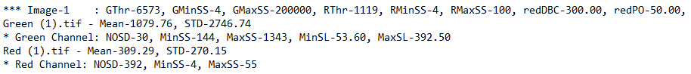

* 1. “Image-“ refer to the number of FOV analyzed. In the example above it is the first FOV.
  2. GThr is the threshold calculated by the software for analyzing the Green channel
  3. GMinSS/GMaxSS are the user defined minimum and maximum shape size for analysis
  4. RThr is the threshold calculated by the software for analyzing the Red channel
  5. RMinSS/RMaxSS are the user defined minimum and maximum shape size for analysis
  6. redDBC is the user defined factor for “Max dist. Btw centers”. Refer to paragraph 5i.
  7. redPO is the user defined factor for “Min overlap percent”. Refer to paragraph 5j.
  8. Green (1).tif is the Green channel image and Mean and STD refer to the mean and std values of the pixels’ intensities of the image.
  9. Green Channel is the Green channel image and NOSD is the number of shapes detected in it, MinSS/MaxSS are the minimum and maximum values of the number of pixels in the detected shapes and MinSL/MaxSL are the minimum and maximum values of the lengths of the detected shapes.
  10. Red (1).tif is the Red channel image and Mean and STD refer to the mean and std values of the pixels’ intensities of the image.
  11. Red Channel is the Red channel image and NOSD is the number of shapes detected in it and MinSS/MaxSS are the minimum and maximum values of the number of pixels in the detected shapes.

1. At the end of the file there is a table with the results used for further analysis:

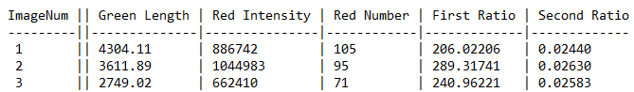

* 1. ImageNum – the number of FOV.
  2. Green Length – the total length of DNA molecules detected in the respective FOV.
  3. Red Intensity – Is the total intensity of all the detected labels in the Red channel.
  4. Red Number – Is the total number of labels detected in the Red channel.
  5. First Ratio – the ratio between the Red Intensity and Green Length.
  6. Second Ratio – the ratio between Red Number and Green Length.

1. Use the provided example images and run the analysis first with default parameters and then changing them one by one and monitoring the different output results. It is a good practice to analyze and save analyzed images from random places in the data set and verify visually that the detection results are satisfying, meaning the detected DNA molecules are the required ones and that the detected labels are counted correctly by comparing to the original overlay of the images.